Introduction to Barometer Sensors
A barometer sensor is an instrument that measures atmospheric pressure, which is the weight per unit area of the vertical column of air above a point on the earth. The barometric pressure at any given location varies continuously due to weather changes and altitude. Barometer sensors allow detection and measurement of these pressure variations.
Barometer sensors are one of the most widely used pressure sensors with applications across weather forecasting, altimeters, scientific research, aerospace systems, industrial processes, medical devices and more. This article provides an in-depth overview of barometer sensor technology, working principles, design considerations and applications.

Working Principle of Barometer Sensors
A barometer sensor works by detecting the force exerted by the atmosphere on a surface due to the weight of the overlying air column. This force gets translated into an electrical signal via different transduction mechanisms.
he BMP180 barometric sensor (model GY-68) is the one in the following figure (front and back view). It is a very small module with 1mm x 1.1mm (0.039in x 0.043in).
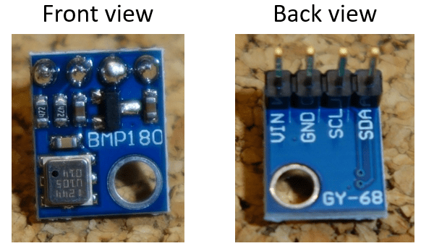
It measures the absolute pressure of the air around it. It has a measuring range from 300 to 1100hPa with an accuracy down to 0.02 hPa. It can also measure altitude and temperature.
The BMP180 barometric sensor communicates via I2C interface. This means that it communicates with the Arduino using just 2 pins.

Pin wiring
Wiring the sensor to the Arduino is pretty straightforward:
Pin | Wiring to Arduino Uno
Vin | 5V
GND | GND
SCL | A5
SDA | A4

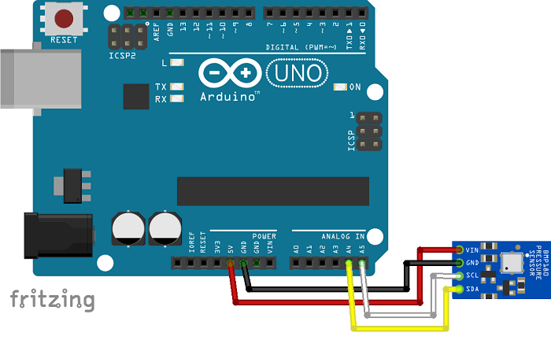

Common Applications of Barometer Sensors

Weather Monitoring
- Meteorology applications like forecasting, storm tracking using barometric pressure changes as an indicator of weather patterns.
- Professional weather stations as well as consumer weather instruments.
- Can detect altitude changes to predict fronts and atmospheric disturbances.

Altimeters
- Used in aircraft, drones, rockets etc to determine altitude and vertical speed by measuring pressure changes during ascent/descent.
- Skydivers use compact wrist altimeters. Hikers use barometric altimeters to measure elevation gain.
- Radar altimeters complement barometric sensors in aircraft for low altitudes.

Personal Health
- Smartwatches and fitness bands use MEMS sensors to provide elevation and climb data.
- Diagnosing conditions like pulmonary edema which cause abnormal pressure changes.
- Monitoring blood pressure trends.

Navigation Systems
- Aircraft, missiles use corrected barometric readings for vertical positioning when GPS lacking.
- Underwater depth gauges and groundwater/soil vapour analysis.

Industrial Processes
- Vacuum, pressure and gas flow measurements in industrial production and research.
- Leak testing, batch/fermentation monitoring, HVAC balancing etc.

Others
- Atmospheric pressure correction of flow meters like mass flow meters.
- Ground vehicles to gauge torque, engine vacuum.
- Pressure-based water level sensors.
- Vibration/acceleration compensation in inertial sensors.

Modern MEMS Barometer Technology
Microelectromechanical systems (MEMS) fabrication has enabled mass production of miniaturized, low cost, low power and highly reliable barometers. Modern MEMS barometers offer:
- Chip-level monolithic integration of sensing element (capacitive/piezoresistive diaphragm) and analog/digital interface electronics for sensing and calibration.
- Small adhesive-mountable packages (as small as 1.5 x 1.5 mm) ideal for wearables and mobile devices. Metal cans for robustness.
- Analog (ratiometric, voltage) or digital (I2C/SPI) interfaces. Use of I2C allows networking multiple sensors.
- Resolution down to 0.01 mbar with accuracy of 1 mbar. Ultra-fine & stable capacitive sensing elements.
- Low power consumption, as low as 3 μA quiescent current. Allow always-on background operation.
- Inbuilt temperature compensation for drift-free operation over wide -40 to 85°C industrial range.
- Low-cost mass production, high integration and miniaturization ideal for consumer device integration.
Sample Code
- #include <SFE_BMP180.h>
- #include <Wire.h>

- // You will need to create an SFE_BMP180 object, here called "pressure":

- SFE_BMP180 pressure;

- #define ALTITUDE 1655.0 // Altitude of SparkFun's HQ in Boulder, CO. in meters

- void setup()
- {
- Serial.begin(9600);
- Serial.println("REBOOT");

- // Initialize the sensor (it is important to get calibration values stored on the device).

- if (pressure.begin())
- Serial.println("BMP180 init success");
- else
- {
- // Oops, something went wrong, this is usually a connection problem,
- // see the comments at the top of this sketch for the proper connections.

- Serial.println("BMP180 init fail\n\n");
- while(1); // Pause forever.
- }
- }

- void loop()
- {
- char status;
- double T,P,p0,a;

- // Loop here getting pressure readings every 10 seconds.

- // If you want sea-level-compensated pressure, as used in weather reports,
- // you will need to know the altitude at which your measurements are taken.
- // We're using a constant called ALTITUDE in this sketch:

- Serial.println();
- Serial.print("provided altitude: ");
- Serial.print(ALTITUDE,0);
- Serial.print(" meters, ");
- Serial.print(ALTITUDE*3.28084,0);
- Serial.println(" feet");

- // If you want to measure altitude, and not pressure, you will instead need
- // to provide a known baseline pressure. This is shown at the end of the sketch.

- // You must first get a temperature measurement to perform a pressure reading.

- // Start a temperature measurement:
- // If request is successful, the number of ms to wait is returned.
- // If request is unsuccessful, 0 is returned.

- status = pressure.startTemperature();
- if (status != 0)
- {
- // Wait for the measurement to complete:
- delay(status);

- // Retrieve the completed temperature measurement:
- // Note that the measurement is stored in the variable T.
- // Function returns 1 if successful, 0 if failure.

- status = pressure.getTemperature(T);
- if (status != 0)
- {
- // Print out the measurement:
- Serial.print("temperature: ");
- Serial.print(T,2);
- Serial.print(" deg C, ");
- Serial.print((9.0/5.0)*T+32.0,2);
- Serial.println(" deg F");

- // Start a pressure measurement:
- // The parameter is the oversampling setting, from 0 to 3 (highest res, longest wait).
- // If request is successful, the number of ms to wait is returned.
- // If request is unsuccessful, 0 is returned.

- status = pressure.startPressure(3);
- if (status != 0)
- {
- // Wait for the measurement to complete:
- delay(status);

- // Retrieve the completed pressure measurement:
- // Note that the measurement is stored in the variable P.
- // Note also that the function requires the previous temperature measurement (T).
- // (If temperature is stable, you can do one temperature measurement for a number of pressure measurements.)
- // Function returns 1 if successful, 0 if failure.

- status = pressure.getPressure(P,T);
- if (status != 0)
- {
- // Print out the measurement:
- Serial.print("absolute pressure: ");
- Serial.print(P,2);
- Serial.print(" mb, ");
- Serial.print(P*0.0295333727,2);
- Serial.println(" inHg");

- // The pressure sensor returns abolute pressure, which varies with altitude.
- // To remove the effects of altitude, use the sealevel function and your current altitude.
- // This number is commonly used in weather reports.
- // Parameters: P = absolute pressure in mb, ALTITUDE = current altitude in m.
- // Result: p0 = sea-level compensated pressure in mb

- p0 = pressure.sealevel(P,ALTITUDE); // we're at 1655 meters (Boulder, CO)
- Serial.print("relative (sea-level) pressure: ");
- Serial.print(p0,2);
- Serial.print(" mb, ");
- Serial.print(p0*0.0295333727,2);
- Serial.println(" inHg");

- // On the other hand, if you want to determine your altitude from the pressure reading,
- // use the altitude function along with a baseline pressure (sea-level or other).
- // Parameters: P = absolute pressure in mb, p0 = baseline pressure in mb.
- // Result: a = altitude in m.

- a = pressure.altitude(P,p0);
- Serial.print("computed altitude: ");
- Serial.print(a,0);
- Serial.print(" meters, ");
- Serial.print(a*3.28084,0);
- Serial.println(" feet");
- }
- else Serial.println("error retrieving pressure measurement\n");
- }
- else Serial.println("error starting pressure measurement\n");
- }
- else Serial.println("error retrieving temperature measurement\n");
- }
- else Serial.println("error starting temperature measurement\n");

- delay(5000); // Pause for 5 seconds.
- }

